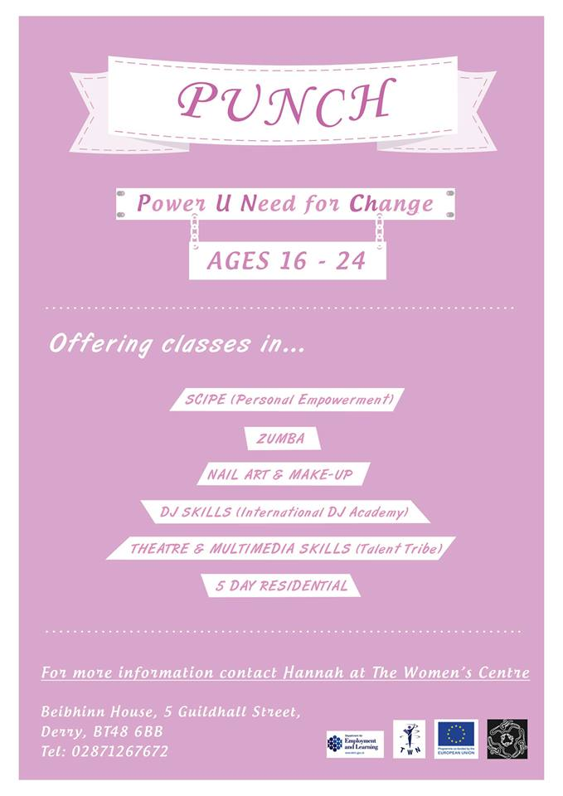

***Make Up & Nail Art***

***Driving Theory***

***Horse-Riding/Horse Care***

***Healthy Cooking***

***DJ Skills***

***Sewing***

***Painting***

***PUNCHurSize***

*For more information contact Clairann at The Women’s Centre*