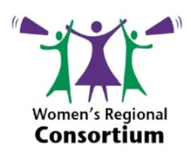
Event
Community Relations and Cultural Awareness Week September 2016
Launch of the Foyle Race Equality Forum
Women’s Regional Consortium/WCD Supported the launch of Foyle Race Equality Forum
Launch of a key organisation which incorporates Black and Minority Ethnic groups across the North West. The Women’s Regional Consortium attended to promote good relations among communities in the North West.
Kat Healy, the Regional Manager of Northern Ireland Council for Ethnic Minorities (NICEM) which provides secretariat support to the Forum, said, “The issues facing Black and Minority Ethnic communities are often quite distinct, including education, employment, access to services, hate crime, advice and many others. The new Forum has been established in order to serve as a channel for these issues to be raised by BME groups and individuals and addressed appropriately. We also hope the new Forum will help more BME members to get involved in local community development and civil society.”
The Foyle Race Equality Forum (FREF) has been established to promote genuine inclusivity of all people from BME communities across the North West. There has been a significant increase in the BME and migrant population of Derry and Strabane in recent times and FREF will help them to engage with statutory agencies and elected representatives, as well as to have a stronger voice. It will also help agencies and elected representatives to understand the needs facing BME people in the North West.
As part of the event WRC made links with NICEM, CRC, UNISON, and other community and voluntary groups and promoted the work of the Women’s Regional Consortium.

