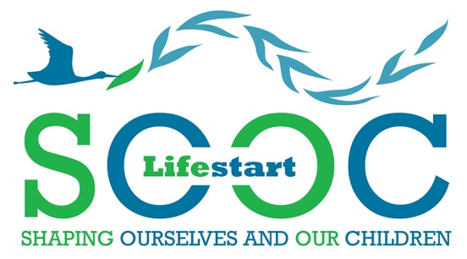
What is SOOC?

“Shaping Ourselves and Our Children”
SOOC is an exciting new course for parents to have fun and learn about how their children develop their emotional and social skills at home. Parents will learn how to support their children to develop these skills and how these will benefit their children later at school, in their community and throughout their lives.
Shaping ourselves and our children will help us as parents explore:
- Hopes and fears we have for our children and their future
- How home shapes our children for the world outside
- Self-esteem and confidence
- Communication skills – what parents say and what children hear
- Learning through Play
- Respect for diversity and our changing communities.
Each course runs for 4 hours X 4 days under the guidance of warm and supportive tutors, lunch is provided and there is a childcare allowance for parents who need childcare. On day four of the course parents and children come together for an interactive play session.
To enrol on the next course please give details to your family visitor, nearest Lifestart office or phone Mary at 028 71 365 363

